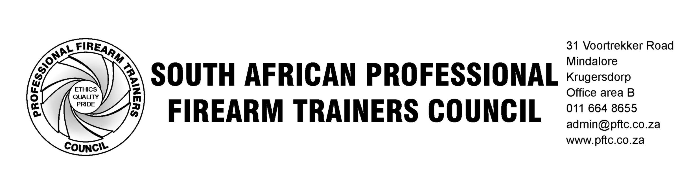

NEWSLETTER NO 22 OF 2013
Travel and Train

We have received a number of queries from training providers on “travel and train”.

The PFTC policy on “travel and train” is as follows:
If an accredited firearm training provider wants to present training in another area, town, or province; the following rules shall apply.
- The practical portion of the training may only take place on an accredited shooting range. Prior written permission for the use of the shooting range must be obtained no less than 7 days before the training takes place. Your written permission must specify that the shooting range is aware of the fact that you are training provider intending to present training on the shooting range, and not simply a member of the public wanting to utilize the facility.

- The classroom which is being used for theoretical training must be either at an existing firearm-accredited venue, located at a shooting range, or an accredited firearm training provider’s premises, due to the fact that the subject being taught is firearms. Even theoretical firearm training requires training aids which could include the use of real firearms (unloaded), dummy firearms, live and dummy ammunition, as visual aids. Using these items in certain schools, technikons, universities, or other training facilities which are not firearm-accredited can be problematic for several different reasons, e.g. gun-free zones, bad public perception, learners carrying own firearms and ammunition, no safe areas/ safe direction for pointing of firearms even if they are unloaded and various others.

- You are required to notify the PFTC ETQA via email at etqa@pftc.co.za of your intention to “travel and train”, the dates of your course, and the venues to be used. This notification must take place no less than 7 days before the training begins. PFTC then has the option to conduct suitable verification, if necessary.
The PFTC is no way unreasonable with regards to “travel and train”. We know the challenges that training providers face and we will be as accommodating as possible, without infringing on standards.

Sincerely,
John Baker
HoD ETQA PFTC

